Release Note

**Product: Cimera**

**Release: 4.3.19**

Date Released: 28/11/2017

Database schema version: 9.0.0

# Applies To

Upgrades from Release 4.2.19

Plug-ins and exits built for release 4.2.19 will need to be replaced with versions built for 4.3.19

# Description

### Highlights:

* + Upgrade from .Net 3.5 to .Net 4.5.2
  + Replace administration system with new Visual Process Modeller (VPM). VPM also available read-only to non-administrators.

* + Updated look & feel of user interface and many usability enhancements.
  + Ability to locally change “Hide Items in Final State” when viewing lists of items and lists of linked items. Ability to configure Item Types to default to hiding or showing related items in a final state.
  + Ability to define an Item Type as a part of another Item Type. Security of child items can be determined by access to the parent. Deleting a parent item automatically deletes all child items.
  + Improved Group & User processing:
    - Add a “home group” for users that belong to multiple groups to select their default group.
    - Improved Group / User UI control to allow cut & paste, auto complete and provide ability to easily set to current user
  + New “calculated fields” – allowing fields to dynamically be set according to formulas.
  + New ability to dynamically hide fields and sections according to rules.
  + Spellchecker, with user-dictionary, added to text fields.
  + Ability for administrators to clear History type fields.
  + Redesigned audit / history display.
  + Ability to define a default sort field and order for item types.
  + Remove JET database support.
  + Process Modeller shows number of user licences required
  + Admin Mode renamed Elevated Mode

# Problems Resolved

# [Problem] PR-715 Messaging Manager - poor error handling

# [Problem] PR-716 Error logging on with Windows 10 when using Windows Authentication: AuthenticationException: A call to SSPI failed

# [Problem] PR-717 Error when exporting to Excel and long text field between 8000 and 8061 chars

# [Problem] PR-718 Indexing manager is not deleting old data when updating items / links resulting in duplicate entries for same item

# [Problem] PR-719 Full-text query preview not working if matches only in file name and not in file content

# [Problem] PR-720 Boolean fields may be marked as changed when they are not

# [Problem] PR-721 Large attached zip file kills indexer with Out of Memory Exception

# Installation

Download the 4.3.19 release install files from <http://www.propelsystems.com/private/dsl/_Cimera%20Installs/4.3.19>

*Follow the standard install / upgrade process in the Installation Guide*

<http://www.propelsystems.com/manuals/cimera/4.3/installationguide/>

**Before starting the Cimera services perform the following checks / actions:**

Database privileges

In the main Cimera SQL Database grant permissions to allow:

* Owner user to “Create View”
* Query and Update users to “Select”

The userids are those specified in the Cimera database:

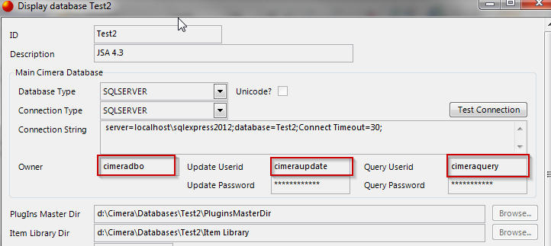

DB Schema

For this upgrade you will need to use Cimera Server Utilities to upgrade the schema of any existing Cimera databases from 8.0.1 to 9.0.0

Config files

Due to the upgrade of .NET the four server configuration files (exe.config) must have the following XML replaced:

Remove:

<supportedRuntime version="v2.0.50727" />

Add:

<supportedRuntime version="v4.0" sku=".NETFramework,Version=v4.5.2"/>

Full Text Index files

The full text indexing subsystem has been upgraded and the existing index needs to be deleted so that it can be rebuilt. Remove all files within the directory defined for the Cimera database(s) defined in Cimera Server Utilities as “Full Text Index Dir”

Rebuild Reporting Databases

Use Cimera Server Utilities to rebuild the reporting database for each Cimera database.

Plug-ins

New versions of any plug-ins (built against 4.3.19) will need to be copied to the plug-ins master directory on the server.

**After starting the Cimera services perform the following checks / actions:**

Validate current configuration and resolve any errors

Log in as an administrator, open the Process Modeller and press the **Validate All** button to identify any configuration that is invalid in the new release. Resolve any errors.

# Reversion

Stop the 4 Cimera Services.

Use Control Panel “Add / Remove Programs” to uninstall the following:

* Cimera Server
* Cimera Server Utilities
* Cimera GUI Client (if installed)

Restore the Cimera database(s). This may be via a database restore or, if an export taken via Cimera Server Utilities, via a reinitialise and import.

Restore the Cimera data directories (plugins, item library, full text index) from the backup taken.

Reinstall 4.2 – the packages can be downloaded from <http://www.propelsystems.com/private/dsl/_Cimera%20Installs/4.2.19>

*Follow the standard install process in the Installation Guide*

<http://www.propelsystems.com/manuals/cimera/4.2/installationguide/>

Remember to replace the server config files with the previously saved 4.2.19 versions before starting Cimera.